EQUATOR RESOLUTION
Institutional Mediation, Conciliation & POSH Support

POSH — Practitioner Guide
For external Internal-Committee members and case support

Workplace & HR Dispute Resolution vertical
July 2026 · Draft for legal sign-off · www.equatorresolution.com

Read this first
Equator supports the Internal Committee; it does not replace it. Nothing in this guide authorises the Institution or any individual to conduct the statutory inquiry in place of a properly constituted Committee, to divert a complaint, or to base a section 10 conciliation on money.

The Committee
A properly constituted Internal Committee under section 4 has a Presiding Officer who is a woman employed at a senior level, at least two members from among employees preferably committed to the cause of women or with relevant social-work or legal experience, and at least one external member from an NGO or association committed to the cause of women, or a person familiar with issues relating to sexual harassment. At least half the members must be women. A Committee that lacks the external member is not properly constituted, and its proceedings are vulnerable.
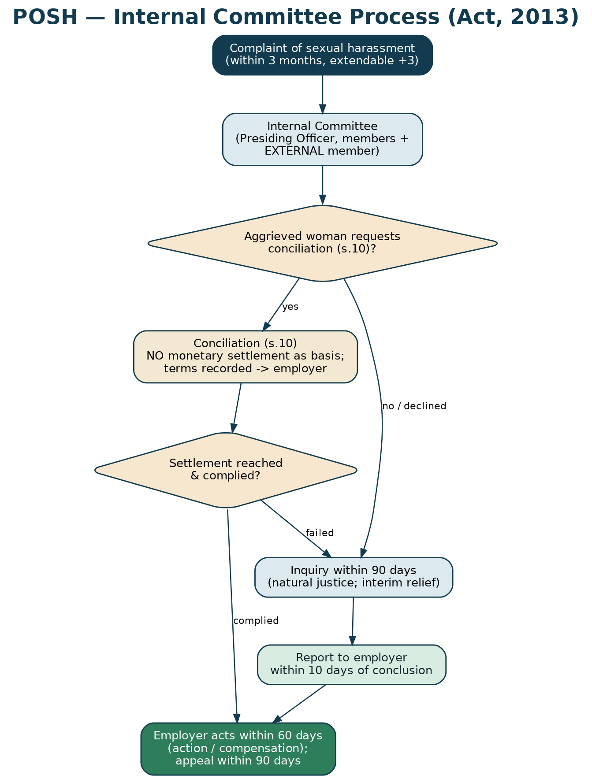
Figure — the statutory process and its timelines.
1. Section 10 conciliation — the narrow gate
Question | The answer
Who may ask for it? | Only the aggrieved woman. The Committee cannot initiate it, and the respondent cannot request it.
When? | Before the inquiry begins.
Can money be the basis? | No. No monetary settlement may be made the basis of conciliation.
What may the terms contain? | Corrective action, an apology, a transfer, an assurance against retaliation, changes to working arrangements — non-monetary undertakings.
What happens to the terms? | The Committee records them and forwards them to the employer for implementation, with copies to both parties.
If the respondent does not comply? | The Committee proceeds with an inquiry.
Does she lose anything by trying? | No. She may opt for an inquiry at any point.

2. Running an inquiry that will stand
- Give the respondent a copy of the complaint and ten working days to reply.
- Hear both parties; allow each to lead evidence and to see the material relied on against them.
- No legal practitioner represents either party in the inquiry.
- Consider interim relief on the complainant's written request — transfer, leave of up to three months in addition to entitlement, or restraining the respondent from appraising her work.
- Complete the inquiry within 90 days; submit the report within 10 days of concluding it.
- Record findings with reasons; recommend action and, where appropriate, compensation.
- The employer acts within 60 days; either party may appeal within 90 days.
Never ask
Do not question a complainant about her character, her dress, her personal life or her sexual history. It is irrelevant, it is harmful, and it will discredit the inquiry.

3. Compensation — the factors
Where compensation is recommended, the Act directs regard to the mental trauma, pain, suffering and emotional distress caused; the loss of career opportunity; medical expenses incurred; the income and financial status of the respondent; and the feasibility of payment, whether in a lump sum or instalments.
4. Malicious complaints — handle with great care
The Act permits action where a complaint is found malicious, or where false evidence or forged documents were produced. But it is explicit that mere inability to substantiate a complaint, or a lack of adequate proof, does not attract this provision. A woman who complains in good faith and cannot prove her case has done nothing wrong. Treating an unproved complaint as a false one is the single most damaging error a Committee can make — it silences everyone watching.
5. Confidentiality (section 16)
The complaint, the identities and addresses of the complainant, respondent and witnesses, the conciliation and inquiry proceedings, and the recommendations and action taken must not be published or made known to the public, press or media. Breach attracts a penalty. Keep papers in a sealed, access-controlled file; do not discuss a matter outside the Committee; do not use identifying detail in the annual report.
6. Records and the annual report
Maintain a register of complaints and the Committee's proceedings. Prepare the annual report in each calendar year, submit it to the employer and the District Officer, and ensure the employer includes the number of cases filed and disposed of in its own annual report. Report numbers, not narratives.

